Computer Language Coding Concepts

Names of Related Items & Related Lists in a Diagram
As said in the article Related Items & Related Lists, every related item and related list has a name. This extends the system interfaces with a Name member. The diagrams below show a Name member inside the system interface of a related item and a related list.

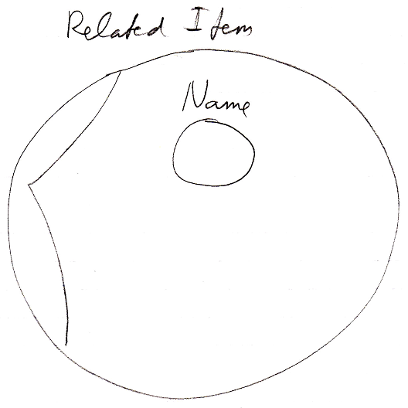

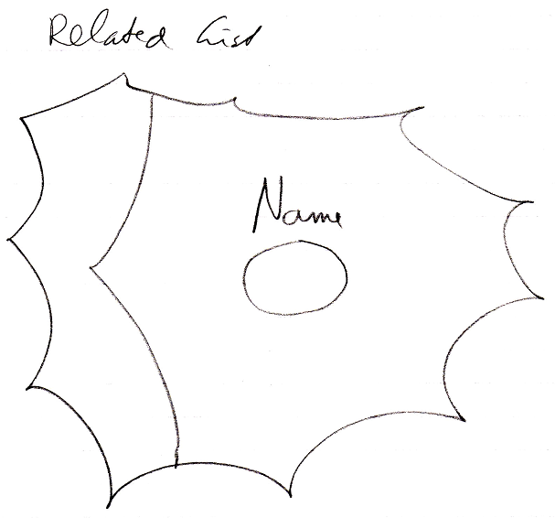

See also: System Objects, Names of Related Items & Related Lists

Author & Copyright: Jan-Joost van Zon Date: July 24, 2008 – July 24, 2008 Location: Oosterhout, The Netherlands Status: Finished

